CDAC Allocation System (DBT)
Name – Vaishnavi Jaju
Roll No – 96234
1) Candidates table 1-----> candidate_id (pk)
CREATE TABLE Candidates (
form_no INT PRIMARY KEY AUTO_INCREMENT,
cc_rank INT NOT NULL UNIQUE CHECK (cc_rank > 0),
name VARCHAR(100) NOT NULL,
category ENUM('A+B') DEFAULT 'A+B'
);
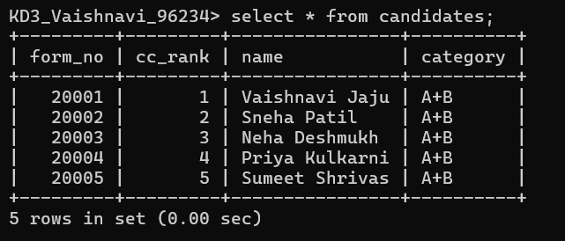
Alter Table Candidates AUTO_INCREMENT=20001;

2) courses tbl 2---------> course_id (pk)
CREATE TABLE Courses (
course_id INT PRIMARY KEY AUTO_INCREMENT,
course_name VARCHAR(100) NOT NULL UNIQUE,
category ENUM('A+B') NOT NULL DEFAULT 'A+B'
);
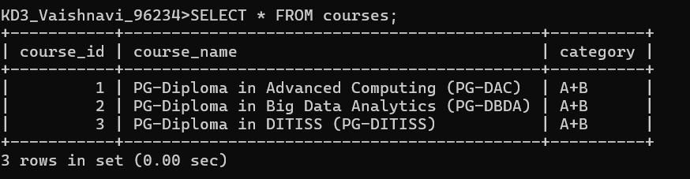

3)centers tbl 3 ----------> (center_id) (pk)
CREATE TABLE Centers (
center_id INT PRIMARY KEY AUTO_INCREMENT,
center_name VARCHAR(100) NOT NULL UNIQUE,
total_seats INT NOT NULL CHECK (total_seats > 0)
);
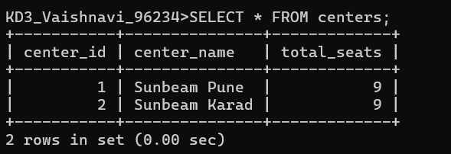

4)CourseCenter------------> ((course_id, center_id)) (pk)

CREATE TABLE CourseCenters (
course_center_id INT PRIMARY KEY AUTO_INCREMENT,
course_id INT, -- FK Courses
center_id INT, -- FK Centers
seats_available INT NOT NULL CHECK (seats_available >= 0),
FOREIGN KEY(course_id) REFERENCES Courses(course_id),
FOREIGN KEY(center_id) REFERENCES Centers(center_id),
UNIQUE(course_id, center_id) -- Composite key
);
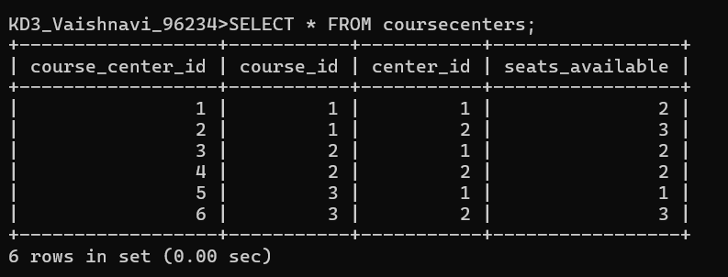

5) preferences tbl 5-------------> (form_no, pref_order) (pk)
CREATE TABLE Preferences (
pref_id INT PRIMARY KEY AUTO_INCREMENT,
form_no INT, -- FK Candidates
course_center_id INT, -- FK CourseCenters
pref_order INT NOT NULL CHECK (pref_order >= 1),
FOREIGN KEY(form_no) REFERENCES Candidates(form_no),
UNIQUE(form_no, pref_order) -- Composite
);
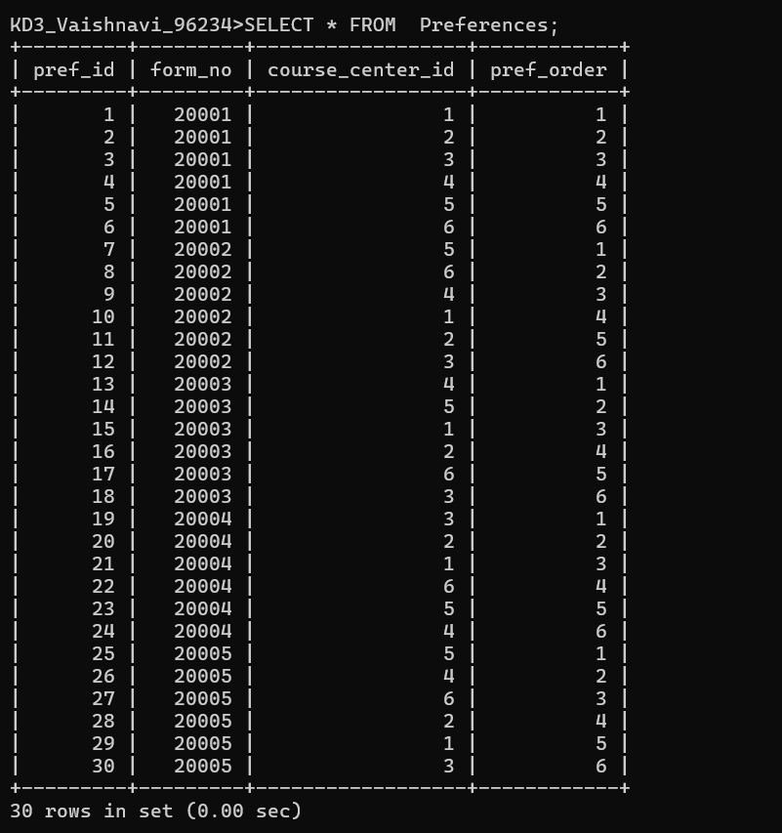
Stored Procedure :-

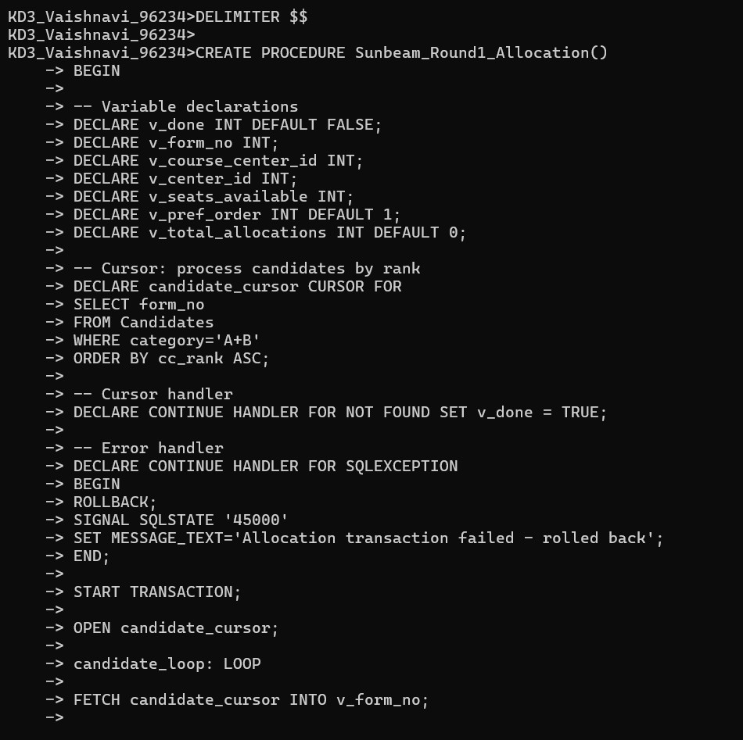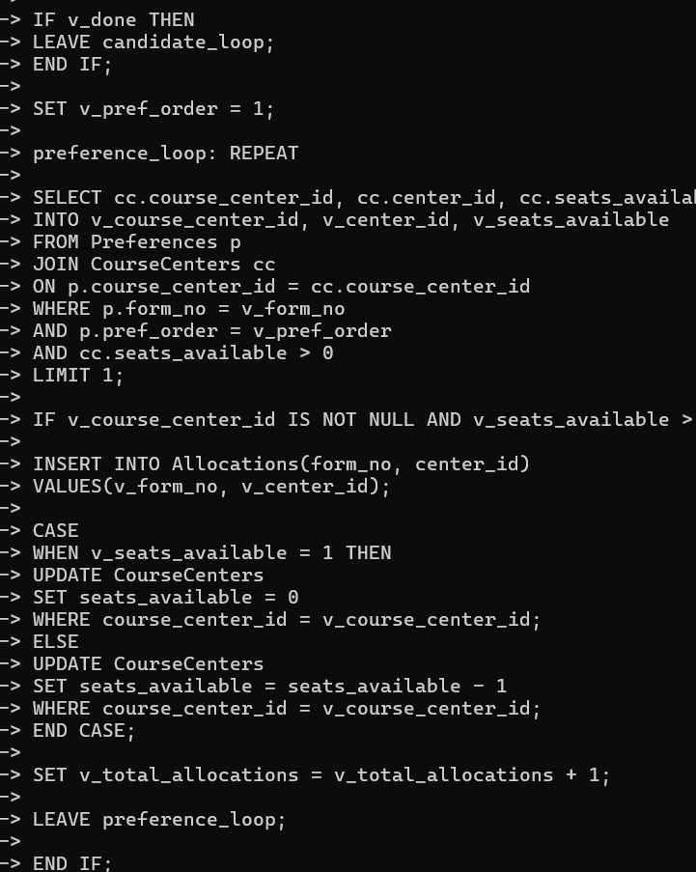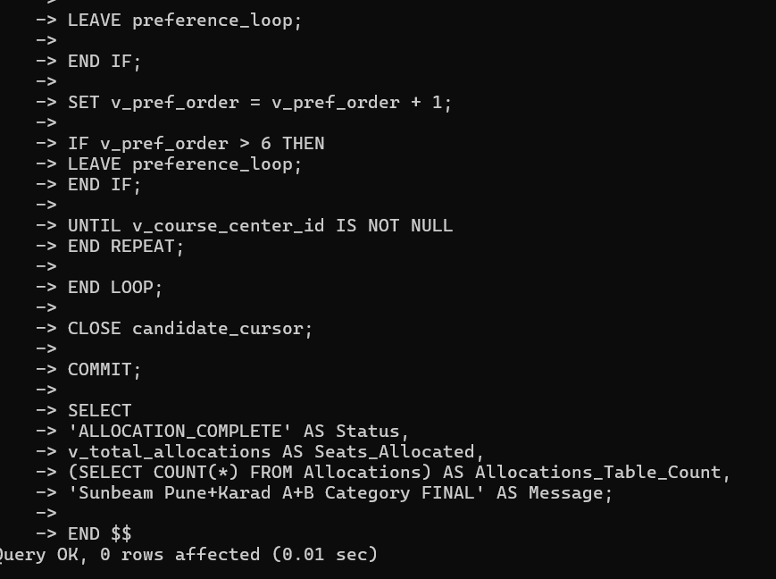
6) allocations tbl 6 -------> form_no (pK) [One student → one seat]

CREATE TABLE Allocations (
allocation_id INT PRIMARY KEY AUTO_INCREMENT,
form_no INT UNIQUE, -- One per candidate in Round 1
center_id INT, -- FK CourseCenters

foreign key(center_id) references Centers(center_id),
FOREIGN KEY(form_no) REFERENCES Candidates(form_no)
);

